Roundup list post template
Meta title  Character limit: 60 | 9 Best Pool Pumps in South Africa | Baracuda
Meta description  Character limit: 140 | Find the best swimming pool pumps in South Africa. We compare their features, price points & more. Read on Baracuda
Focus keyphrase | Best pool pumps
Surfer credit
Suggested URL (/60) | /blog/best-pool-pumps-south-africa/
Keyword research sheet link | Add a link to your keyword research sheet.  Keyword research sheet - template
Internal link opportunities | In doc
Images

H1: 9 Best Pool Pumps in South Africa
Choosing the right swimming pool pump is essential for keeping your water clean, healthy, and circulating efficiently. With so many options available, it can be challenging to know which pump offers the best balance of reliability, performance, and long-term value.
In this guide, we compare the top single-speed, multi-speed, variable-speed, and solar-ready pool pumps available in South Africa. You’ll find clear information on flow performance, energy efficiency, price ranges, and recommended pool sizes to help you choose a pump that suits your needs and budget.
Whether you have a compact backyard pool or a larger in-ground system, this roundup highlights proven, dependable pumps trusted by South African homeowners.
If you’d like expert guidance, you can contact us directly or find a pool store that stocks Baracuda products near you.
Key takeaways

- Single-speed pumps are the most affordable and straightforward choice for everyday use in residential pools - options include the Baracuda Titan 2 SS, Quality SWIMFLO2, Quality Superflo 2, and Zodiac Flo Ease.
- Multi-speed and variable-speed pumps offer greater control and long-term energy savings - great options include the Baracuda Titan 2 Eco3, BLU52 Sunflo 2 ECO 3, Baracuda Titan 2 EcoVS, Zodiac FloPro VS, and the solar-ready Speck BADU®Solar Smart.
- Choosing the right pool pump depends on your pool size, the level of energy efficiency you want, and your budget (we cover expected costs below).

H2: How much does a pool pump cost in South Africa?
Pool pump prices in South Africa vary depending on the motor size and whether the pump is single-speed, multi-speed, variable-speed, or solar-ready.
Single-speed models, such as the Baracuda Titan 2 SS and Quality SWIMFLO2, are the most affordable and typically range from R3,300 to R6,500.
Multi-speed pumps, including the Baracuda Titan 2 Eco3 and BLU52 Sunflo 2 ECO 3, usually range from R6,000 to R10,000.
For maximum efficiency, variable-speed pumps like the Baracuda Titan 2 EcoVS and Zodiac FloPro VS generally cost R8,600 to R16,500.
When budgeting, consider not only the upfront cost but also energy savings, warranty coverage, and long-term running expenses.
Use our interactive map to find a store near you that stocks Baracuda products.

Table of contents

H1: 10 Best Pool Pumps in South Africa
H2: How much does a pool pump cost in South Africa?
H2: Best Single-speed Swimming Pool Pumps in South Africa
H2: Best Multispeed Swimming Pool Pumps in South Africa
H2: What Is the Best Swimming Pool Pump in South Africa?
H2: Final Thoughts on the Best Pool Pumps in South Africa

H2: Best Single-speed Swimming Pool Pumps in South Africa
Single-speed pool pumps remain a favourite for South African households thanks to their affordability, straightforward operation, and dependable everyday performance. These pumps run at a fixed speed, making them ideal for homeowners who want simple, reliable water circulation without the complexity of programmable settings.

In this section, we compare the leading single-speed options—including the Baracuda Titan 2 SS, Quality SWIMFLO2, Quality Superflo 2, and Zodiac Flo Ease—to help you find a durable, cost-effective pump that suits your pool size and budget.

H3: 1. Baracuda Titan2 SS - Reliable & cost-effective with energy-efficient IE2 motor

The Baracuda Titan 2 SS is a durable, single-speed pool pump designed for reliable everyday circulation in South African residential pools.

Powered by an energy-efficient IE2-rated motor, it delivers strong performance with quieter operation and reduced electricity use.

Available in four motor sizes, the Titan 2 SS is suitable for everything from small plunge pools to larger residential pools. It’s a practical, value-for-money choice for homeowners who want simple, dependable filtration with minimal maintenance.

H4: Key Specifications
- Motor type: Single-speed high-efficiency IE2 motor
- Output range: 0.37kW – 1.10kW
- Voltage: 230V
- Horsepower range: 0.5 HP – 1.5 HP
- Temperature rating: 80°F
- Compatible with saltwater and chlorinated pools
- Supports solar heating systems
- Warranty: 2 years

H4: Available Sizes & Recommended Pool Volumes
Model | Power Output | Horsepower | Recommended Pool Size
Titan 2 SS – 0.37kW | 0.37kW | 0.5 HP | Up to ±30,000L (plunge pools)
Titan 2 SS – 0.55kW | 0.55kW | 0.75 HP | Around ±45,000L
Titan 2 SS – 0.75kW | 0.75kW | 1 HP | Up to ±60,000L (family pools)
Titan 2 SS – 1.10kW | 1.10kW | 1.5 HP | Up to ±80,000L

H4: Construction & Features
- Self-priming for easy setup and operation
- Durable, corrosion-resistant casing
- Quiet and low-vibration performance
- Compact footprint ideal for space-saving installations
- Easy to service with minimal maintenance required
- Designed for long-term use in outdoor conditions

H4: Pricing & Where To Buy
The Titan 2 SS is priced between R3,950 and R6,200, depending on the selected power output (0.37kW to 1.1kW).
Positioned in the mid-range category, the Titan 2 SS offers excellent value for money. It combines durable design, high-efficiency performance, and a 2-year warranty.
Use our interactive map to find a pool store near you that stocks Baracuda products to purchase the Titan 2 SS.

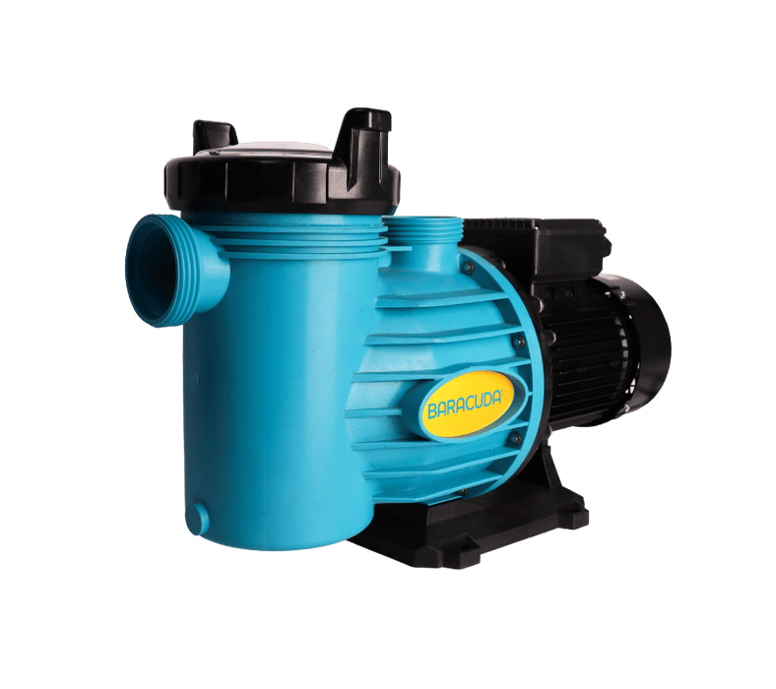

H3: 2. Quality SWIMFLO2 Series – Reliable, all-round single-speed pumps for everyday residential pools
The Quality SWIMFLO2 Series is a well-established range of single-speed pool pumps built for dependable, everyday performance in South African residential pools.
Known for their robust construction and long-standing local reputation, these pumps offer a strong balance of durability and affordability.
Available in multiple motor sizes, the SWIMFLO2 range suits small to large pools and provides straightforward, effective circulation with minimal upkeep. It’s a practical choice for homeowners who want a reliable pump that delivers solid performance without added complexity.

H4: Available Sizes & Recommended Pool Volumes
Model | Power Output | Horsepower | Recommended Pool Size | Recommended Filter
SWIMFLO 2 – 0.55 kW | 0.55 kW | 0.75 HP | Up to ± 30 000 L (small/medium pools) | 2-bag sand filter
SWIMFLO 2 – 0.75 kW | 0.75 kW | 1 HP | Up to ± 60,000 L (family-sized pools) | 3-bag sand filter
SWIMFLO 2 – 1.10 kW | 1.10 kW | 1.5 HP | Up to ± 80 000 L (large residential pools) | 4-bag sand filter
SWIMFLO 2 – 1.50 kW | 1.50 kW | 2 HP | Up to ± 150 000 L (extra-large pools / shared systems) | 5-bag sand filter

H4: Key Specifications
- Motor type: Standard single-speed induction motor
- Output range: 0.55 kW – 1.50 kW
- Voltage: 230 V (single-phase)
- Temperature rating: Typically 60 – 80 °C operating range
- Compatible with saltwater and chlorinated pools
- Solar heating compatible (on 0.75 kW + models)
- Warranty: 2 years

H4: Construction & Features
- Self-priming design for easy installation and startup
- Durable, corrosion-resistant casing built for outdoor environments
- Composite stainless-steel shaft with ¾″ ceramic seal for reliability
- Quiet operation ideal for residential settings
- Compact footprint and simple maintenance access
- Proven long-term durability in South African conditions

H4: Pricing & Where to Buy
The Quality SWIMFLO2 Series typically retails between R 3 300 and R 6 700, depending on motor size and supplier.
It’s a strong mid-range option for homeowners seeking a balance between affordability and performance.
These pumps are distributed through Quality Pool & Spa Products and are available via most local pool equipment retailers and online stores across South Africa.

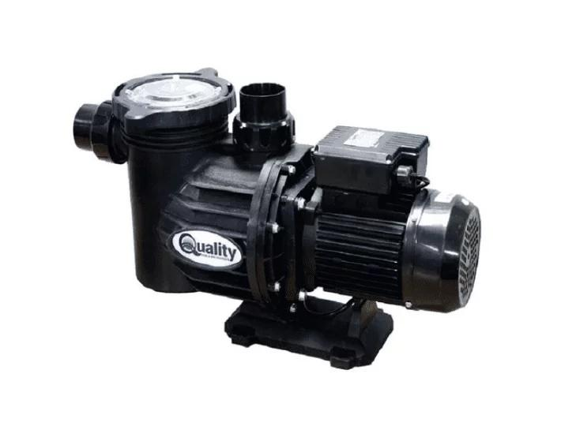

H3: 3. Quality Superflo 2 (non-SF2 series) – Trusted single-speed pump for small to medium-sized residential pools
The Quality Superflo 2 (non-SF2 series) is a long-standing favourite among South African pool owners thanks to its reliable, no-fuss performance.
Designed for small to medium-sized pools, it provides consistent water circulation with minimal maintenance and is well-known for its durability and ease of servicing.
Its simple operation and solid build make it a popular choice for everyday residential filtration, especially for homeowners looking for an affordable pump that’s proven to last. With a strong track record across the country, the Superflo 2 remains one of the most dependable single-speed options in its class.

H4: Available Sizes & Recommended Pool Volumes
Model | Power Output | Horsepower | Voltage | Recommended Pool Size | Recommended Filter
Superflo – 0.55 kW | 0.55 kW | 0.75 HP | 230 V | Up to ± 30 000 L (plunge/small pools) | 2-bag sand filter
Superflo – 0.75 kW (SP230) | 0.75 kW | 1 HP | 230 V | Up to ± 60,000 L (medium pools) | 3-bag sand filter
Superflo – 0.75 kW (SP380) | 0.75 kW | 1 HP | 380 V | Up to ± 60,000 L (medium pools) | 3-bag sand filter

H4: Key Specifications
- Motor type: Standard single-speed motor
- Output range: 0.55 kW – 0.75 kW
- Voltage options: 230 V (single-phase) and 380 V (three-phase)
- Temperature rating: 71 °F (0.55 kW 230 V) / 80 °F (0.75 kW models)
- Compatible with saltwater and chlorinated pools
- Solar-heating compatibility: Yes (especially 0.75 kW models)
- Warranty: 2 years

H4: Construction & Features
- Self-priming design for easy start-up and operation
- Lightweight, thermoplastic casing for outdoor use
- Quiet, low-vibration performance
- Composite shaft with ¾″ ceramic seal for corrosion resistance
- Simple maintenance and servicing
- Available in both single- and three-phase for flexible installations

H4: Pricing & Where to Buy
The Quality Superflo 2 is typically priced between R 3 500 and R 5 000, depending on motor size and voltage configuration.
It’s an affordable, entry-level choice for homeowners seeking a proven, low-maintenance pump that balances cost and reliability.
The range is distributed through Quality Pool & Spa Products and stocked by most pool stores and online marketplaces across South Africa.
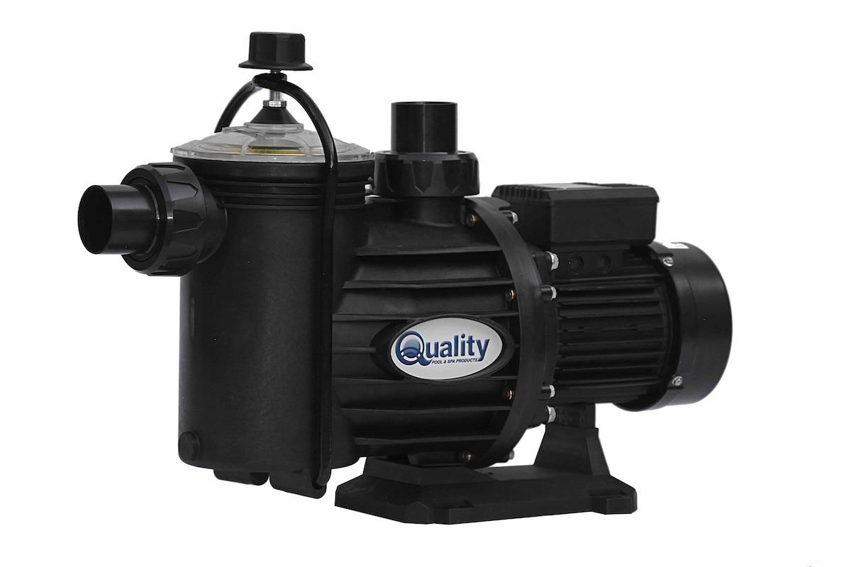

H3: 4. Zodiac Flo Ease Pump Range – Durable single-speed pool pumps for reliable everyday circulation
The Zodiac Flo Ease Pump Range is built for reliable, low-maintenance circulation in South African residential pools. Made from corrosion-resistant materials and designed with a compact, user-friendly layout, it delivers steady performance across a wide range of pool sizes.
With three motor options available, the Flo Ease series offers a strong mix of efficiency, quiet operation, and long-term durability. It’s a solid choice for homeowners who want a trusted single-speed pump that handles day-to-day filtration with ease.

H4: Available Sizes & Recommended Pool Volumes
Model | Power Output | Horsepower | Recommended Pool Size | Recommended Filter
Flo Ease 0.55 kW | 0.55 kW | 0.75 HP | Up to ± 30 000 L (small/medium pools) | 2-bag sand filter
Flo Ease 0.75 kW | 0.75 kW | 1 HP | Up to ± 60,000 L (family-sized pools) | 3-bag sand filter
Flo Ease 1.10 kW | 1.10 kW | 1.5 HP | Up to ± 90 000 L (larger residential pools) | 4-bag sand filter

H4: Key Specifications
- Motor type: Single-speed, energy-efficient induction motor
- Voltage: 230 V single-phase
- Flow rate: Optimised for steady filtration and circulation cycles
- Pool compatibility: Suitable for chlorinated and saltwater pools
- Solar heating is compatible with all models
- Warranty: 2 years (Zodiac / Fluidra SA)

H4: Construction & Features
- Durable UV- and corrosion-resistant pump housing
- Transparent strainer lid for quick inspection and cleaning
- Large debris basket for improved filtration performance
- Quiet, low-vibration motor operation
- Self-priming design for flexible installation above or below the water level
- Compact footprint ideal for space-limited pump rooms

H4: Pricing & Where to Buy
The Zodiac Flo Ease Pump Range typically retails between R 3 800 and R 6 500, depending on the motor size and retailer.
This range offers excellent value for money within the single-speed category—combining Zodiac’s reputation for build quality with accessible pricing.
The Flo Ease series is available through pool stores near you that stock Zodiac products.

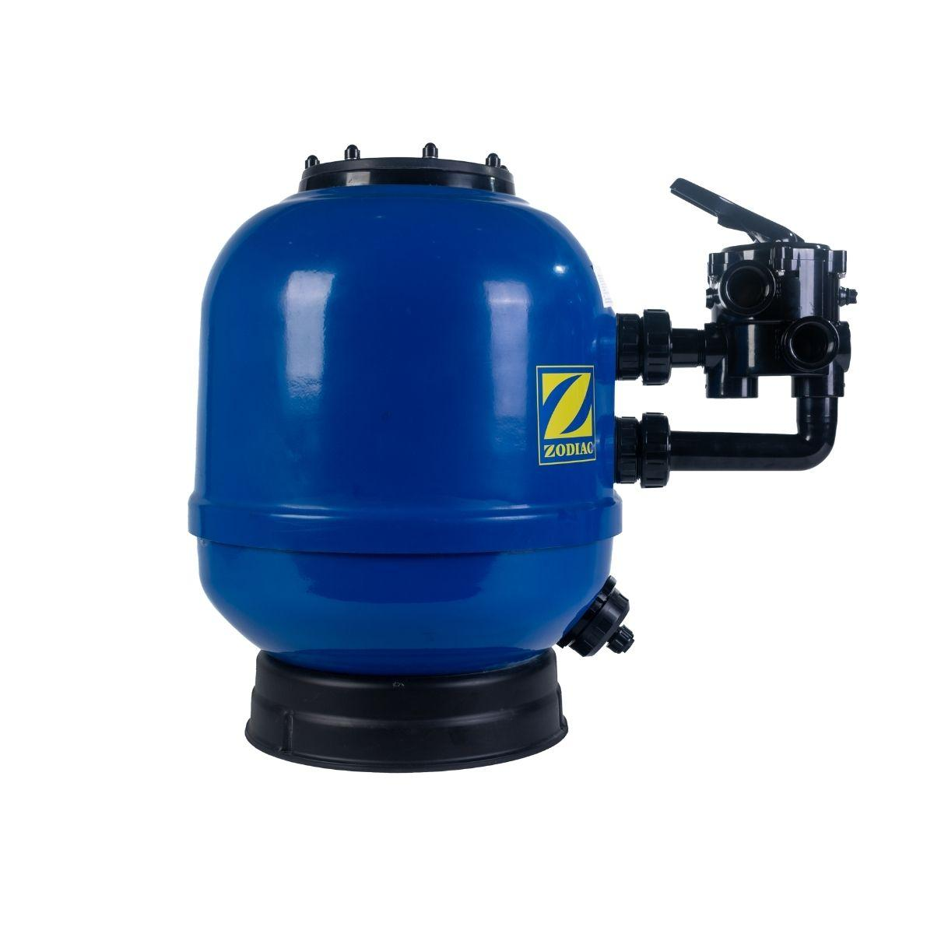

H3: 5. BLU52 Sunflo 2 Speed Pool Pump – Energy-efficient dual-speed pump for flexible performance
The BLU52 Sunflo 2 Speed Pool Pump combines solid build quality with energy-efficient operation, offering a versatile option for homeowners who want control over performance and power consumption.
With dual-speed functionality, it can run quietly on low speed for everyday filtration and switch to high speed for vacuuming, backwashing, or peak flow requirements.
Backed by Fluidra’s trusted BLU52 brand, it’s designed to deliver both reliability and efficiency for South African pool systems.

H4: Available Sizes & Recommended Pool Volumes
Model | Power Output | Horsepower | Recommended Pool Size | Recommended Filter
Sunflo 0.55 kW | 0.55 kW | 0.75 HP | Up to ± 30 000 L (small/medium pools) | 2-bag sand filter
Sunflo 0.75 kW | 0.75 kW | 1 HP | Up to ± 60,000 L (family-sized pools) | 3-bag sand filter
Sunflo 1.10 kW | 1.10 kW | 1.5 HP | Up to ± 80 000 L (larger residential pools) | 4-bag sand filter

H4: Key Specifications
- Motor type: Two-speed motor (low/high settings)
- Voltage: 230 V single-phase
- Energy efficiency: Up to 30–40% lower power consumption on low speed
- Temperature rating: Suitable for standard residential applications (~60 °C)
- Pool compatibility: Chlorinated and saltwater systems
- Warranty: 2 years (via Fluidra / BLU52 distribution network)

H4: Construction & Features
- Dual-speed functionality for improved energy management
- Quiet operation during filtration cycles on low speed
- Corrosion- and UV-resistant housing for long outdoor life
- Transparent strainer lid with large debris basket
- Self-priming design for flexible above- or below-waterline installation
- Compact design suited to most existing plumbing configurations

H4: Pricing & Where to Buy
The BLU52 Sunflo 2 Speed Pool Pump typically retails between R 4 000 and R 6 500, depending on the selected motor size and supplier.
It’s widely recognised for its balance between cost, performance, and energy savings, making it one of the most practical upgrades for residential pool systems.
Please refer to the BLU52 website for a list of available including major online retailers like Takealot and Makro.

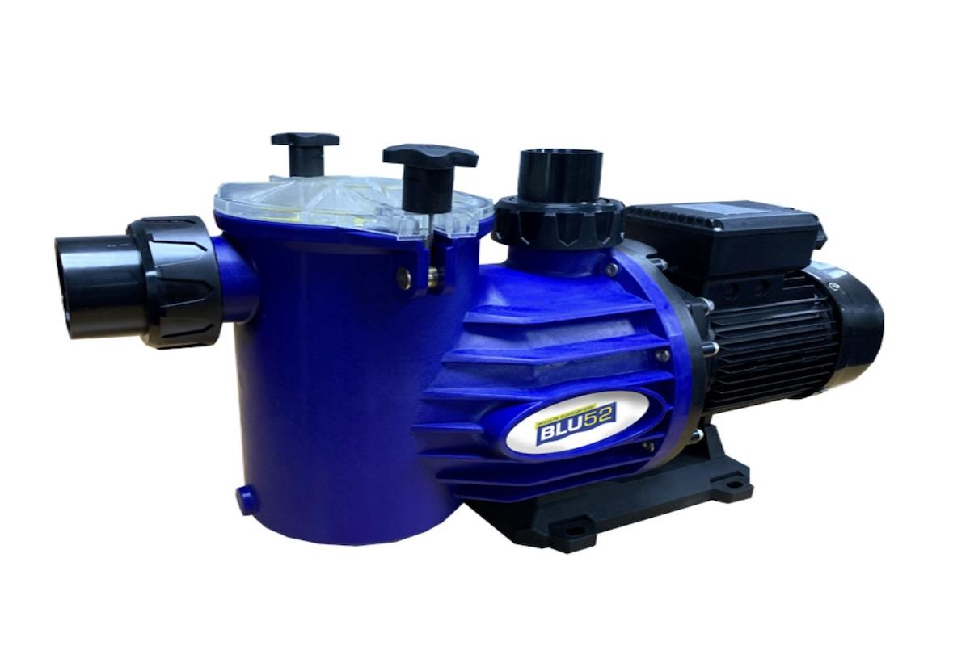

H2: Best Multispeed Swimming Pool Pumps in South Africa
Multi-speed pool pumps are a great choice for homeowners who want better energy efficiency and more control over their pool’s circulation.
These pumps let you switch between lower speeds for everyday filtration and higher speeds for tasks like backwashing or vacuuming.

In this section, we highlight the top multi-speed options available in South Africa, showcasing pumps that offer quieter operation, flexible performance settings, and meaningful long-term electricity savings for residential pools.

H3: 6. Baracuda Titan 2 Eco3 – Three-speed energy-saving pump for efficient residential pools
The Baracuda Titan 2 Eco3 builds on the trusted Titan 2 range with enhanced three-speed functionality designed to improve energy efficiency. Its adjustable speed settings allow homeowners to fine-tune performance for everyday filtration, heating, or cleaning, helping reduce electricity use without compromising flow.

Quiet and easy to operate, the Eco3 is engineered by Fluidra South Africa and offers a strong balance of power and long-term cost savings. It’s an excellent fit for those looking for a more efficient upgrade from a standard single-speed pump.

H4: Available Sizes & Recommended Pool Volumes
Model | Power Output | Horsepower | Recommended Pool Size | Recommended Filter
Titan 2 Eco3 – 0.75 kW | 0.75 kW | 1 HP | Up to ± 60,000 L (family-sized pools) | 3-bag sand filter
Titan 2 Eco3 – 1.10 kW | 1.10 kW | 1.5 HP | Up to ± 80 000 L (larger residential pools) | 4-bag sand filter
Titan 2 Eco3 – 1.50 kW | 1.50 kW | 2 HP | Up to ± 120 000 L (large or shared systems) | 5-bag sand filter

H4: Key Specifications
- Motor type: Three-speed induction motor (low, medium, high settings)
- Voltage: 230 V single-phase
- Energy efficiency: Up to 60% power savings compared to single-speed pumps
- Control: Manual selector switch for speed mode adjustment
- Pool compatibility: Saltwater and chlorinated systems
- Temperature rating: Standard residential (60 – 80 °C)
- Warranty: 2 years (Fluidra SA)

H4: Construction & Features
- Durable, UV-stabilised pump housing with reinforced seal system
- Quiet, low-vibration operation across all speed modes
- Transparent strainer lid for easy inspection and maintenance
- Large debris basket to reduce clogging and improve filtration cycles
- Self-priming design for flexible installation above or below the water level
- Designed for reduced wear on filtration equipment and longer motor life

H4: Pricing & Where to Buy
The Baracuda Titan 2 Eco3 typically retails between R 6 000 and R 9 000, depending on motor size and retailer.
It’s a mid-to-premium choice for homeowners who want the flexibility of multi-speed operation without the price tag of a fully variable-speed pump.
To purchase the Baracuda Titan2 Eco3, you can find a pool store near you that stocks Baracuda products using our interactive map.
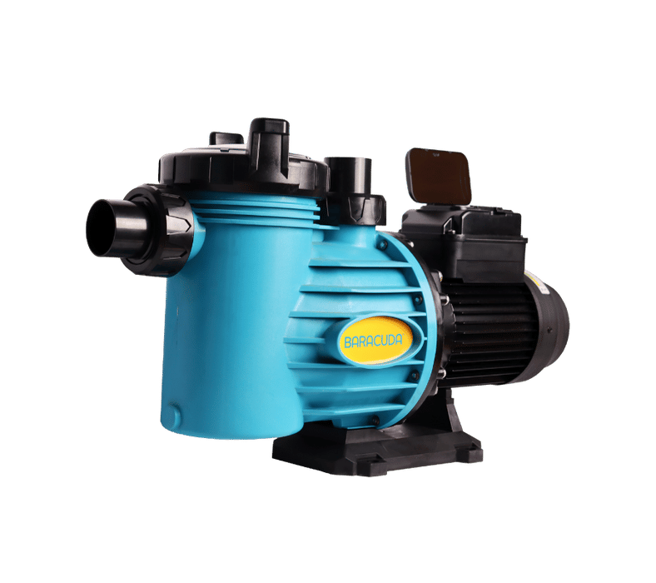

H3: 7. Baracuda Titan 2 EcoVS – Premium variable-speed pump for quiet, energy-efficient performance
The Baracuda Titan 2 EcoVS is the flagship pump in the Titan series, offering fully variable-speed operation for maximum energy efficiency and exceptionally quiet performance.
Its inverter motor and built-in speed controls allow homeowners to fine-tune circulation for filtration, heating, or cleaning while significantly reducing electricity use—often by up to 70% compared with traditional single-speed models.
Engineered by Fluidra South Africa, the EcoVS is an excellent choice for households wanting a premium, future-focused upgrade that delivers powerful performance, long-term savings, and smooth, quiet operation in residential pools.

H4: Available Sizes & Recommended Pool Volumes
Model | Power Output | Horsepower | Recommended Pool Size | Recommended Filter
Titan 2 EcoVS – 0.75 kW | 0.75 kW | 1 HP | Up to ± 60,000 L (family-sized pools) | 3-bag sand filter
Titan 2 EcoVS – 1.10 kW | 1.10 kW | 1.5 HP | Up to ± 80 000 L (large residential pools) | 4-bag sand filter
Titan 2 EcoVS – 1.50 kW | 1.50 kW | 2 HP | Up to ± 120 000 L (large or heated systems) | 5-bag sand filter

H4: Key Specifications
- Motor type: Fully variable-speed inverter motor
- Control: Digital touch interface with programmable speed profiles
- Voltage: 230 V single-phase
- Energy efficiency: Up to 70% less power use compared to single-speed models
- Speed range: 600 – 3,450 RPM
- Noise level: < 50 dB at low speed (whisper-quiet operation)
- Pool compatibility: Saltwater and chlorinated systems
- Warranty: 2 years (Fluidra SA standard)

H4: Construction & Features
- Advanced inverter motor for precise, efficient speed control
- Robust, corrosion-resistant housing for long-term durability
- Integrated thermal and overload protection
- Quiet operation ideal for residential areas
- Large transparent debris basket and twist-lock lid
- Self-priming pump design for flexible installation
- Compatible with automation and timer systems

H4: Pricing & Where to Buy
The Baracuda Titan 2 EcoVS is positioned as a premium energy-efficient pool pump, typically priced between R8,600 and R16,500, depending on the motor size and retailer.
While the upfront cost is higher than that of traditional single-speed pumps, its variable-speed inverter technology can significantly reduce monthly electricity use, helping homeowners lower long-term running costs.

To purchase the Baracuda Titan2 EcoVS, you can locate a pool store near you that stocks Baracuda products using our interactive map.



H3: 8. Zodiac FloPro Variable Speed Pump – Premium 1.5 kW inverter-driven pump for large, energy-efficient pools
The Zodiac FloPro Variable Speed Pump is a premium, high-efficiency option built for larger residential pools that need strong, reliable circulation.
Its 1.5 kW inverter motor provides fully adjustable speed control, allowing homeowners to fine-tune flow for filtration, heating systems, or water features while reducing energy use by up to 70% compared with single-speed pumps.
Engineered with durable materials and advanced performance features, the FloPro VS delivers powerful, quiet, and efficient operation, making it one of the most capable variable-speed pumps in the South African market.

H4: Available Sizes & Recommended Pool Volumes
Model | Power Output | Horsepower | Recommended Pool Size | Recommended Filter
FloPro VS 1.50 kW | 1.50 kW | 2 HP | Up to ± 120 000 L (large residential or heated pools) | 5-bag sand filter

H4: Key Specifications
- Motor type: Fully variable-speed inverter motor
- Voltage: 230 V single-phase
- Speed range: 600 – 3,450 RPM
- Digital interface: LCD control panel with preset speed modes
- Energy efficiency: Up to 70% lower power usage than single-speed models
- Flow rate: Up to 30 m³/h (depending on installation)
- Noise level: ≈ 45–50 dB at low speed for whisper-quiet operation
- Pool compatibility: Saltwater and chlorinated systems
- Warranty: 2 years (Zodiac / Fluidra SA standard)

H4: Construction & Features
- Robust inverter motor designed for continuous operation and long life
- Digital touch interface for precise speed and timer control
- Corrosion-resistant and UV-stable housing suitable for outdoor environments
- Large, easy-access strainer lid for fast maintenance
- Quiet, low-vibration motor with integrated thermal protection
- Self-priming for versatile above- or below-waterline installations
- Compatible with automation systems and solar pool setups

H4: Pricing & Where to Buy
The Zodiac FloPro Variable Speed Pump (1.5 kW) generally retails between R11,500 and R16,500, depending on the supplier and any installation extras.
While the upfront price is higher than a standard single-speed pump, its inverter-driven efficiency can help reduce monthly electricity costs, making it a strong long-term option for larger residential pools.

The Zodiac FloPro Variable Speed Pump is available through pool stores near you that stock Zodiac products.

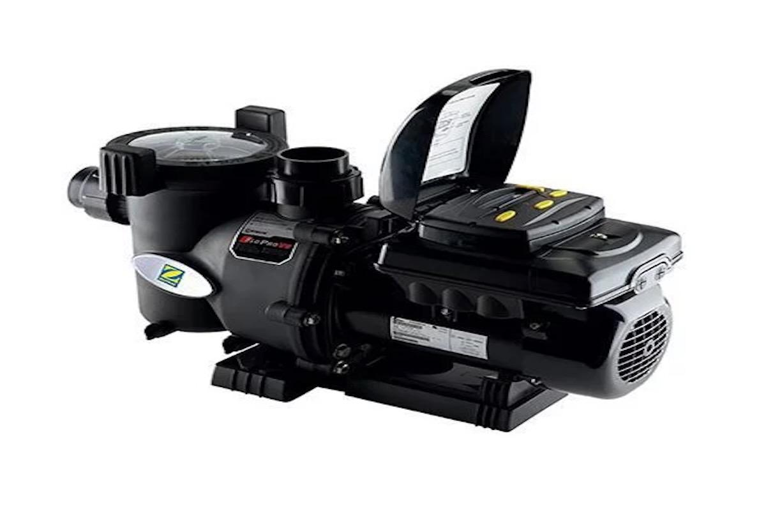

H3: 9. BLU52 Sunflo 2 ECO 3 Pool Pump – 0.75 kW 230 V – Three-speed energy-saving pump for efficient, quiet circulation
The BLU52 Sunflo 2 ECO 3 Pool Pump is a versatile three-speed model designed to improve energy efficiency while giving homeowners more control over their pool’s circulation.

Its adjustable low, medium, and high-speed settings allow you to optimise performance for everyday filtration, backwashing, or cleaning without unnecessary power use.

Compact, durable, and simple to operate, the ECO 3 is a strong choice for families looking for a more efficient upgrade from a standard single-speed pump—offering good performance, lower running costs, and reliable operation in South African conditions.

H4: Available Sizes & Recommended Pool Volumes
Model | Power Output | Horsepower | Recommended Pool Size | Recommended Filter
Sunflo 2 ECO 3 – 0.75 kW | 0.75 kW | 1 HP | Up to ± 60,000 L (family-sized pools) | 3-bag sand filter

H4: Key Specifications
- Motor type: Three-speed motor (low/medium/high settings)
- Voltage: 230 V single-phase
- Energy efficiency: Up to 60% lower power use than single-speed models
- Control: Manual speed selector switch on motor housing
- Temperature rating: Standard residential (60 – 80 °C)
- Pool compatibility: Saltwater and chlorinated systems
- Warranty: 2 years (via Fluidra / BLU52 network)

H4: Construction & Features
- Triple-speed operation for optimised filtration and power efficiency
- Quiet, low-vibration performance on low and medium modes
- Corrosion-resistant pump housing built for South African conditions
- Transparent strainer lid for easy maintenance checks
- Self-priming design for above/below waterline installation
- Large debris basket to reduce clogging and improve circulation

H4: Pricing & Where to Buy
The BLU52 Sunflo 2 ECO 3 Pool Pump (0.75 kW 230 V) typically retails between R6,000 and R8,000, depending on the retailer and any installation extras.
It’s a cost-effective upgrade for homeowners who want more control and improved energy efficiency compared with traditional single-speed pumps, without the higher price tag of a full variable-speed model.
Visit the BLU52 website to see where to buy, including online retailers such as Takealot and Makro.

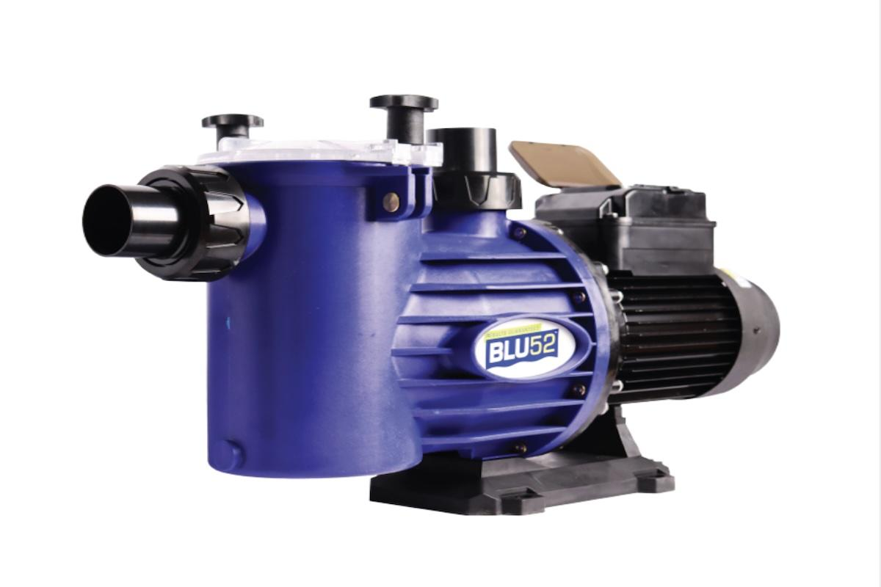

Second value add section.

H2: What is the Best Swimming Pool Pump in South Africa?
The best swimming pool pump for your home depends on your pool size, the level of energy efficiency you want, and how much control you’d like over circulation and performance.
For everyday reliability, single-speed pumps like the Baracuda Titan 2 SS and Quality SWIMFLO2 are excellent choices. They’re affordable, easy to maintain, and well-suited to small and medium-sized pools that need consistent, no-fuss circulation.
If you want better control and improved efficiency, multi-speed pumps such as the Baracuda Titan 2 Eco3 and BLU52 Sunflo 2 ECO 3 offer flexible speed settings that help reduce electricity use during daily filtration while still delivering strong performance for cleaning and backwashing.
At the premium end, variable-speed pumps like the Baracuda Titan 2 EcoVS and Zodiac FloPro VS provide the highest level of energy savings, quieter operation, and precise speed adjustment, making them ideal for larger or frequently used pools.
For households exploring renewable options, variable-speed pumps such as the Baracuda Titan 2 EcoVS and Zodiac FloPro VS work exceptionally well with solar power when the system is carefully designed and correctly installed. The effectiveness of this setup depends on factors such as solar capacity, inverter compatibility, and how the pump is programmed.
Tip: Match your pump to both your pool’s volume and your preferred level of energy efficiency. Single-speed pumps suit simple setups, while variable-speed or solar-ready models provide the best long-term running costs.
Ready to choose your pump? Use our interactive map to find a pool store near you that stocks Baracuda products or contact us to get advice from our experts.

H2: Final Thoughts on the Best Pool Pumps in South Africa
Ready to upgrade your pool system with a reliable, efficient pool pump?
Browse our full range of pool pumps to find models suited to every pool size, setup, and budget. Whether you prefer a single-speed pump like the Baracuda Titan 2 SS, or a variable-speed option like the Baracuda Titan 2 EcoVS or Zodiac FloPro VS, each pump in this guide delivers strong, proven performance for South African pools.
Still weighing up your options? Here are a few helpful tips.
- Start by matching the pump to your pool’s requirements. Consider your pool volume, turnover needs, and whether you run additional equipment like solar heating or water features.
- If lowering running costs is a priority, look at multi-speed or variable-speed pumps—they offer far better energy efficiency than traditional single-speed models.
- Installation and maintenance also matter. A self-priming, corrosion-resistant pump can simplify setup and help ensure long-term durability in outdoor conditions.
- Eco-conscious homeowners can explore solar-compatible variable-speed models such as the Baracuda Titan 2 EcoVS and Zodiac FloPro VS, which are well-suited to renewable energy systems when correctly designed and installed.
If you need help choosing the right pump for your pool, you can contact us for personalised advice from our team. You can also use our interactive map to find a pool store that stocks Baracuda products near you.
You can also find related articles helpful for pool owners on our blog, including best swimming pool cleaners, weekly pool maintenance tips, and more.

